CAB432 Mandatory Proposal:

**Overall mashup purpose and description:**

With my mashup proposal I will be using Zomato to search for a restaurant, then I will be using Edaman to see whether their meals are healthy and Flickr to display the meals images based on the restaurant I have chosen.

**User stories**

As a user I want to search for restaurants that I want to go to with the Zomato API.

As a user I want to find out how healthy the meal is by using their menu information to search the Edaman nutrition API.

**List of service and data APIs to be utilised. This must include a short description of the API (1-2 sentences is fine), and a list of the services to be used for each user story (see**

**above).**

Note: I wrote a lot of information for my own understanding of the API’s.

**Zomato:**

Zomato API’s gives you access to the freshest and most exhaustive information for over 1.5 million restaurants across 10,000 cities globally.

With Zomato’s API you can search for the restaurants name, cuisine or location.

You can display the detailed information which includes the ratings, location and the cuisine.

You can also use the Zomato foodie index to show great areas to dine in a city.

**Flickr:**

Flickr is great for online photo management and sharing application, With flickr members can upload photos, share them securely, supplement their photos with metadata such as license information, geo-location, people, tags and interact with their family, friends or anyone in the community.

**The Nutrition Analysis API of Edaman:**

By copying and pasting any food recipe you will learn its nutrition details in under a second.

Edaman returns detailed information for each ingredient, line for the Recipe Analysis or for each text string for the Text Analysis, you can get information for the entire recipe as a whole or broken down automatically for each ingredient.

For each food, it returns data for calories, fats, carbohydrates, protein, cholesterol, sodium for a total of ___ macros and it’s micronutrients.

All food nutrients data is enriched with diet, allergy and health labelling as calculated by Edaman based on the food’s ingredients, such as being vegan, paleo, gluten free, low-sodium, dairy free and 35+ other claims that generated automatically.

**A clear statement of the division between server side and client-side processing, and the technologies to be deployed.**

The application will be deployed in a docker container, and the application will be using the Zomato’s api data with a table of all the restaurants available, then after choosing the restaurant and pressing the enter button, there’ll be a list of meals available in the specific restaurant with an image of the restaurant and once you have chosen the meal, there’ll be a list of ingredients in the meal in a table and an image of the meal, and there you can choose which ingredients you want to look at the nutrition’s off.

**Maybe a mock-up of the application page:**

**Client Side:**

All restaurant’s will be displayed in the table and you can either search for the restaurant or click on the restaurant to get, the meals in the specific restaurant.

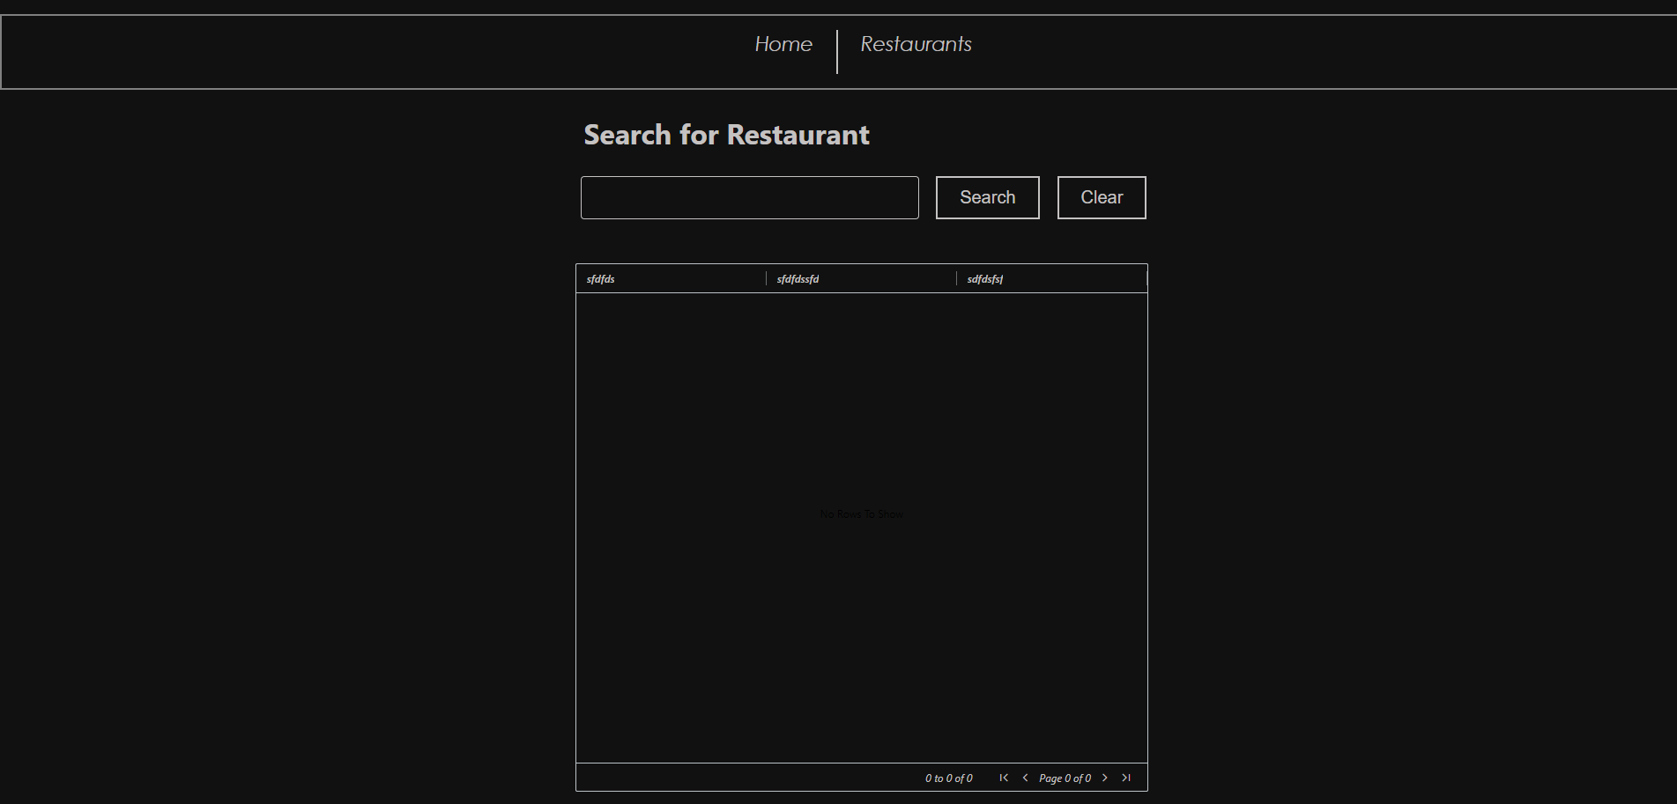

Once button is pressed

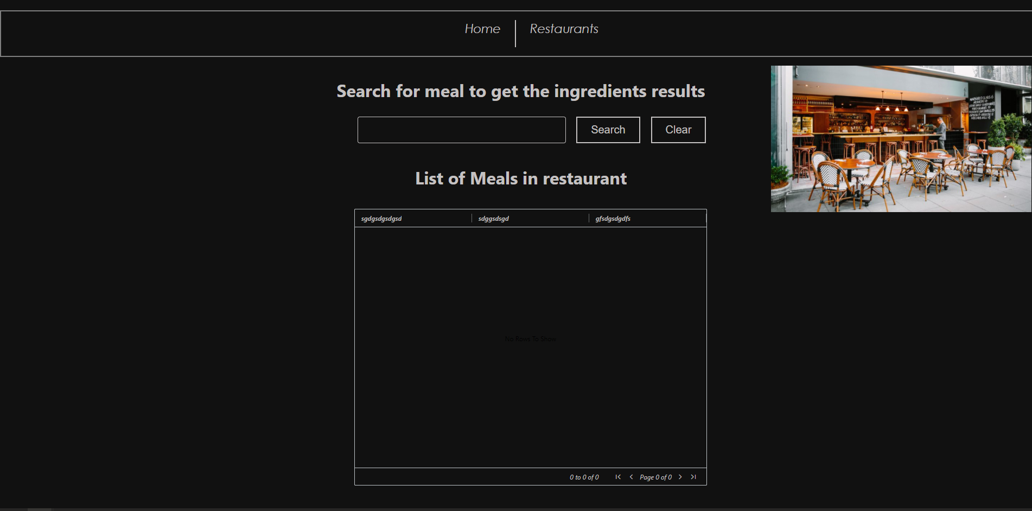

There’ll be an image of the restaurant and a list of meals you can choose from, and once you have searched for the meal or selected the meal

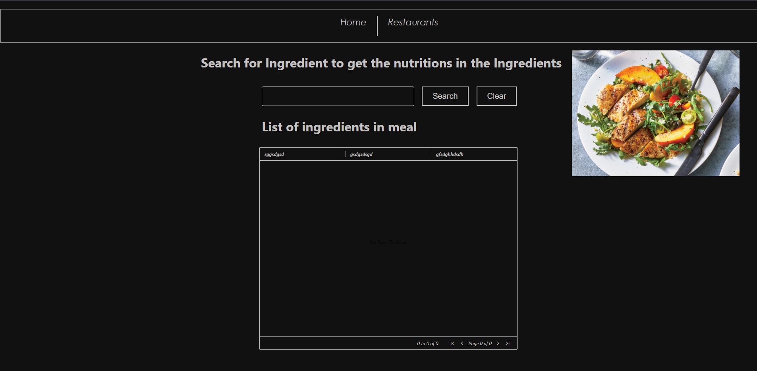

There’ll be an image of the meal you have selected and a list of ingredients, where you can search for the nutrition’s in the meal and once you have selected the ingredient.

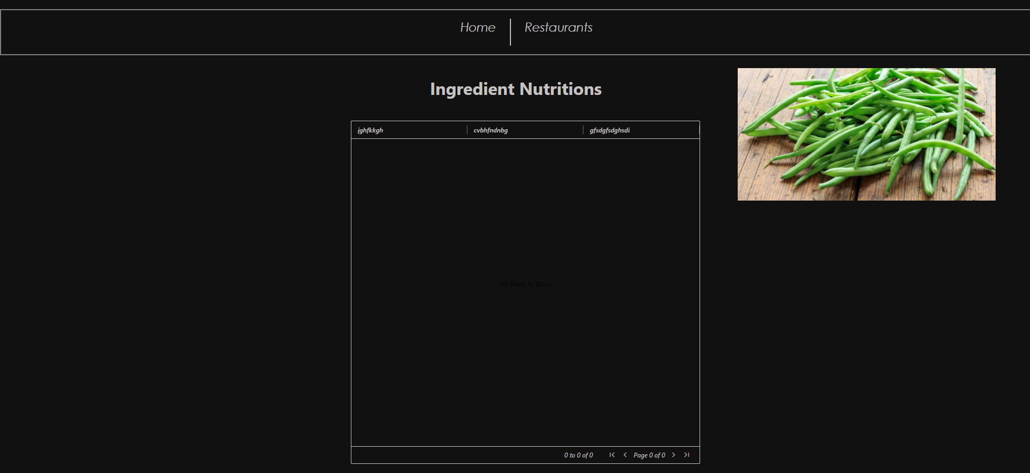

This will show you, the carbs, fats, protein etc. in the meal

Cc [j.hogan@qut.edu.au](mailto:j.hogan@qut.edu.au) and [trjstewart@gmail.com](mailto:trjstewart@gmail.com)